Convolution of MACD + RSI based on Maxwell-Boltzmann distribution to create the “Raffasya v.1.0” indicators during Brexit referendum 2019

Abstract. On March 2019, Brexit vote to be continued and after the vote, there was a decrease in the correlation between the directly involved currencies GBP and EUR. Classical technical analysis indicators will be difficult to determine the direction of high volatility processing trends. This research creates a technical analysis indicator “Raffasya v.1.0” based on statistical mechanics with Maxwell-Boltzmann distribution for financial investment with several stages: (1) convolution of OHLC GBP currency’s chart substituted to MACD and RSI indicators; (2) convolution of MACD (histogram and slow line), RSI, OHLC, and volume of GBP currency’s candle into the Maxwell-Boltzmann distribution; (3) created the algorithm of Maxwell-Boltzmann convolution with programming script as the MQL4 and MQL5 for “Raffasya v.1.0” indicators using MetaQuote software; (4) test of net income and relative drawdown of the “Raffasya v.1.0” indicators on GBP currency before and after UK Parliament vote on Brexit deal March 2019 using MetaTrader 4 and MetaTrader 5. The spectrum of “Raffasya v.1.0” indicators is a new technical analysis developed using statistical mechanics based on Maxwell-Boltzmann distribution. This indicator can provide high accuracy in investment decisions and quickly identify MACD + RSI’s anomaly. So that net income obtained is higher with low risk.
- Introduction
The Brexit referendum, conclude that most European financial markets displayed negative correlations after the referendum [1]. On the 23rd of June 2016, when UK citizens decided to leave the European Union (EU), in the referendum known as Brexit, financial markets reacted immediately. The future of the UK economy has remained uncertain since then, with many concerns about the evolution of the UK´s macroeconomic variables [2]. On the March 2019, Brexit vote to be continued [3] and after the vote, there was a decrease in the correlation between the directly involved currencies (i.e. GBP and EUR) and the safe-haven currencies (i.e. CHF, JPY, and gold) while there was an increase in the correlation among the safe-haven currencies.
Macroeconomic policies frequently have a significant impact on the overall economic performance of an economy [4]. Signaling theory of exchange determination posits that central bank intervention operations signals changes in the future monetary policy and affects the behavior of other market participants [5]. Furthermore, studying mathematical models of a large number of interacting economic agents, econophysics has much common ground with agent-based modeling and simulation. Historically, statistical mechanics was developed in the second half of the nineteenth century by James Clerk Maxwell, Ludwig Boltzmann, and Josiah Willard Gibbs. These physicists believed in the existence of atoms and developed mathematical methods for describing their statistical properties. There are interesting connections between the development of statistical physics and statistics of social phenomena [6-10].
For example [7][9][10] the fundamental law of equilibrium statistical mechanics is the Boltzmann-Gibbs law, which states that the probability distribution of energy ε is P(ε) = Ce^{−ε/T}, where T is the temperature, and C is a normalizing constant. The main ingredient that is essential for the textbook derivation of the Boltzmann-Gibbs law is the conservation of energy. The closed economic system, the total amount of money is conserved. Thus the equilibrium probability distribution of money P(m) should follow the Boltzmann-Gibbs law P(m) = Ce^{−m/T}. Here m is money, and T is an effective temperature equal to the average amount of money per economic agent. The conservation law of money reflects their fundamental property that, unlike material wealth, money (more precisely the fiat, ‘paper’ money) is not allowed to be manufactured by regular economic agents, but can only be transferred between agents.
Moving Average Convergence Divergence (MACD) and Relative Strength Index (RSI) are indicators of classical technical analysis used for decision making on financial investments, gold, silver, oil, CFDs, Futures, and stock indices. MACD was constructed by Gerald Appel, an analyst and money manager in New York [11]. It consists of three EMAs which will generate two signal lines, the fast MACD line and slow signal line [12]. Their crossovers give the trading signals i.e. “Buy” and “Sell”. RSI an oscillator, introduced by J. Welles Wilder, Jr., is based upon the difference between the average gains vs. the average loss over a given period [13] and compares the magnitude of a stock’s recent gains to the magnitude of its recent losses [14].
The combination of these two indicators is often used to estimate the direction and strength of the trend. A Brexit vote is an international event which will affect the global financial system, especially the currency market. This market is the largest in the world and the currencies directly involved in the vote, namely GBP and EUR, are two of the major currencies. Classical technical analysis indicators will be difficult to determine the direction of high volatility processing trends. So that new technical analysis is needed more accurately using statistical mechanics with the convolution of MACD + RSI based on Maxwell-Boltzmann distribution.

- Method
Sets of tick-by-tick “trade” data at time frame 15 minute provided by MetaTrader 4 [15] and MetaTrader 5 [16] for the GBPUSD exchange rate for the period of 03/01/2019 to 03/29/2019 during Brexit referendum 2019. This research creates a technical analysis indicator “Raffasya v.1.0” based on statistical mechanics with Maxwell-Boltzmann distribution for financial investment with several stages: (1) convolution of OHLC GBP currency’s chart substituted to MACD(12,26,9) and RSI(14) indicators; (2) convolution of MACD(12,26,9) (histogram and slow line), RSI(14), OHLC, and volume of GBP currency’s candle into the Maxwell-Boltzmann distribution; (3) created the algorithm of Maxwell-Boltzmann convolution with programming script as the MQL4 [15] and MQL5 [16] namely “Raffasya v.1.0” indicators using MetaQuote software; (4) test of net income and relative drawdown of the “Raffasya v.1.0” indicators on GBP currency before and after UK Parliament vote on Brexit deal March 2019 using MetaTrader 4 and MetaTrader 5.

- Result and Discussion
Financial closing price (close price) is the most important price in trading shares in the financial sector. The closing price of the financial sector can be used as a basis for forming a new price index related to financial sector returns as explained in the research of N Rahmawati and T E Lestari [17]. The dynamics of GBPUSD TF 15 minutes during the Brexit referendum are presented in Figure 1 below with parameters of closing prices and volumes from 01-01-2019 to 03-29-2019. Based on volume data shows that there are high fluctuations on 03-05-2019 and 03-12-2019 with candle values ​​above 800 pips (5 decimal places).

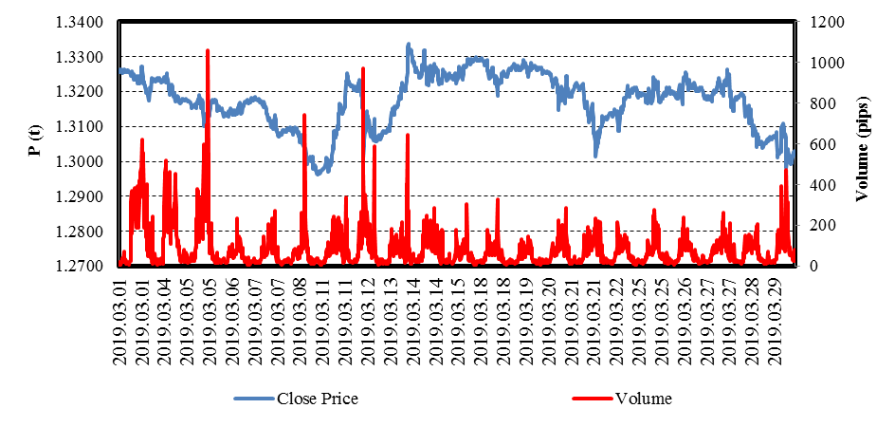

Figure 1. Distribution of GBPUSD prices TF 15 minutes during Brexit referendum 01-03-2019 until 03-29-2019

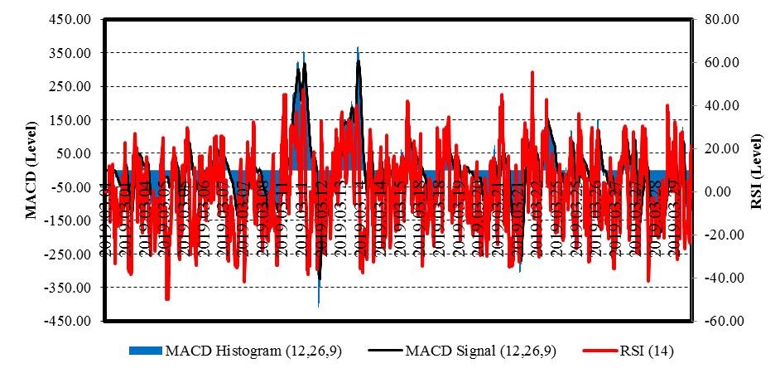

Figure 2. Distribution of MACD(12,26,9) and RSI(14) convolution results at GBPUSD prices TF 15 minutes during Brexit referendum 01-03-2019 until 03-29-2019

The GBPUSD’s OHLC data is carried out by convolution with the Good Distance of Spectrum approach [18] on the MACD(12,26,9) and RSI(14) indicators (see equation number (1)). The calculation of the MACD(12,26,9) indicator convolutions uses the MACD equation found by Gerald Appel [11][12] while the RSI(14) convolutions use the equation found by J. Welles Wilder, Jr. [13][14]. The results of the convolution calculation are shown in the following Figure 2. MACD(12,26,9) and RSI(14) convolution uses Maxwell-Boltzmann's general distribution [19] (see equation number (2)) using analog references [8][9] in the following formula in Table 1.

G(D) = G₀ + G₁D + + … + G_{m}D^{m} | (1)

(2)

Table 1. Convolution of MACD(12,26,9) + RSI(14) based on Maxwell-Boltzmann distribution

Goal | Input | Convolution calculation process | Output
π | 3.14 | 3.14 | π
N | RSI | N = (RSI – 50)² | N
m | MACD Histogram | m = (MACD Histogram)² | m
k | 1,38 × 10⁻²³ | k = 1,38 × 10⁻²³ | k
T | Close Price | T = Close Price | T
v | Volume | v = Volume | v
MB₁ | π, N, m, k, and T |  | MB₁
MB₂ | m, v, k, and T |  | MB₂
MB | MB₁ and MB₂ | MB = MB₁ × MB₂ | MB
Correction of MB | MB |  | Corr. of MB
MB Level | Corr. of MB | MB Level = IF((Corr. of MB)<10,(Corr. of MB),10) | MB Level
Raffasya Level | MB Level | Raffasya Level = 10 – MB Level | Raffasya Level

Figure 3 (a) shows Maxwell-Boltzmann distribution convoluted with MACD (12,26,9) and RSI (14) at GBPUSD price TF 15 Minutes, there are three high peak volatility n(v) on 03-11-2019, 03-12-2019, and 03-14-2019. The spectrum model of Maxwell-Boltzmann convolution on MACD(12,26,9) and RSI(14) resembles the spectrum of plasma species N₂-H₂ in a previous study by Herdianto et al [20][21].
MB level as a basis for making the spectrum of "Raffasya v.1.0" indicators is shown in Figure 3 (b). The spectrum of "Raffasya v.1.0" indicators is shown in Figure 3 (c) which explains the safe position when entering an investment marked with a white spectrum. The closing position is shown when the spectrum penetrates the middle level in consideration of an accurate closing price. Although the Brexit referendum has a high risk on the GBPUSD market, the spectrum of "Raffasya v.1.0" indicators can show the right and safe position for investment entry.
Fundamentally on March 7, 2019, the British Parliament voted on Brexit agreement which was postponed until March 30, 2019, resulting in positive sentiment (bullish). The spectrum of “Raffasya v.1.0” indicators show a bullish signal when the European session which is the same as MACD and RSI indicators. When the American session MACD and RSI indicators expressed a reversal trend but the spectrum of “Raffasya v.1.0” indicators remained optimistic about sustainability trend (see Figure 4). MACD and RSI indicators showed trend anomalies, but in fact, the trend continued until the American session closed with a net profit of 230 pips (23.00%) like as “Raffasya v.1.0” signal. Relative drawdown when applied the spectrum of “Raffasya v.1.0” indicators less than 2.00%.

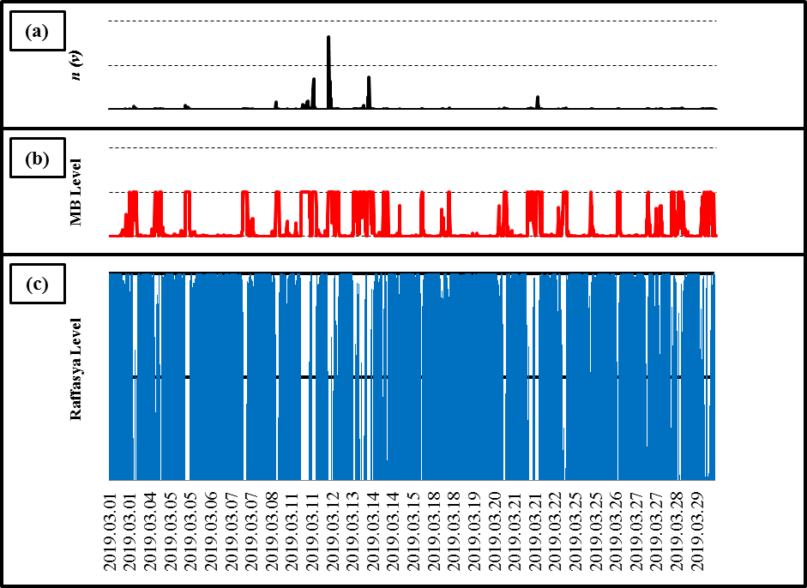

Figure 3. The MACD(12,26,9) and RSI(14) convolution results using Maxwell-Boltzmann distribution as a “Raffasya v.1.0” indicators on GBPUSD Prices TF 15 minutes during Brexit referendum at 01-03-2019 until 03-29-2019

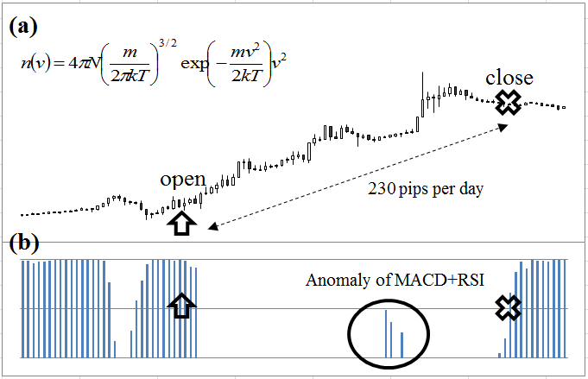

Figure 4. Display of MetaTrader4 and MetaTrader5: (a) chart of GBPUSD candlestick TF 15 minutes during Brexit referendum 2019; (b) the spectrum of “Raffasya v.1.0” indicators.

- Conclusion
The spectrum of “Raffasya v.1.0” indicators is a new technical analysis developed using statistical mechanics based on Maxwell-Boltzmann distribution. This indicator can provide high accuracy in investment decisions and quickly identify MACD + RSI’s anomaly. So that net income obtained is higher with low risk.

Acknowledgments
The authors would like to thank Mrs. P Novianti as a Corporate Financial Manager from Monex Investindo Futures Inc., in the Sahid Sudirman Center 17th floor, Jenderal Sudirman Street Kav. 86, Jakarta 10220, Indonesia for the research facilities provided as well as guidance for the implementation of the research using MIFX Mobile, MetaTrader 4, and MetaQuote with Account Number 92066552.

References
[1] Mohti W, Dionísio A, Vieira I, and Ferreira P 2019 Physica A 525 1388
[2] Guedes E F, Ferreira P, Dionísio A, and Zebende G F 2019 Physica A 523 1175
[3] Besselink L F M, Swider K, and Michel B 2019 Representation of Member States in the Council: Voting Power The impact of the UK’s withdrawal on the institutional set-up and political dynamics within the EU (European Parliament) chapter 2 pp 10-36
[4] Dayyabu S, Adnan A A, and Sulong Z 2016 Int. J. of Eco. & Fin. 6 (1) 279
[5] Kaminsky G L and Lewis K K 1996 J. of Mon. Eco. 37 (2) 285
[6] Mantegna R N, Palagyi Z, and Stanley H E 1999 Physica A 274 216
[7] Dragulescu A and Yakovenko V M 2000 Eur. Phys. J. B 17 723
[8] Mantegna R N and Stanley H E 2004 An Introduction to Econophysics Efficient market hypothesis (Cambridge: Cambridge University Press) chapter 2 pp 8-13
[9] Cockshott W P, Cottrell A F, Michaelson G J, Wright I P, and Yakovenko V M 2009 The statistical mechanics of money Classical Econophysics (New York: Routledge) chapter 8 pp 148-160
[10] Yakovenko V M 2009 Rev. Mod. Phys. 81 (4) 1703
[11] Anghel G D I 2015 Proc. Eco. & Fin. 32 1414
[12] Appel G 2005 Advanced Moving Average Convergence-Divergence (MACD): The Ultimate Market Timing Indicator? Technical Analysis (Power Tools for Active Investors) ed Boyd J (New York: Financial Times Prentice Hall) chapter 8 pp 165-200
[13] Agrawal J G, Chourasia V S, and Mittra A K 2013 IJAREEIE 2 (4) 1360
[14] Wilder J W 1979 The Relative Strength Index New Concepts in Technical Trading Systems (Winston-Salem: Hunter Publishing) section 6 pp 63-70
[15] MetaQuotes Software Corporation 2019 MetaTrader 4 Trading Platform downloaded from https://www.metaquotes.net/en/metatrader4 (Cyprus -Limassol)
[16] MetaQuotes Software Corporation 2019 MetaTrader 5 Trading Platform downloaded from https://www.metaquotes.net/en/metatrader5 (Cyprus -Limassol)
[17] Rahmawati N and Lestari T E 2019 Jurnal Matematika 9 (1) 11
[18] Johannesson R and Zigangirov K S 1999 Convolutional Codes with Good Distance Properties Fundamental of Convolutional Coding ed Hoyt R F (New York: The Institute of Electrical and Electronics Engineers, Inc.) chapter 8 pp 347-370
[19] Laurendeau N M 2005 Nonequilibrium Statistical Thermodynamics: Elementary Kinetic Theory Statistical Thermodynamics (Cambridge: Cambridge University Press) section 15 pp 289-300
[20] Herdianto H, Santjojo D J D H, and Masruroh 2017 AIP Conf. Proc. 1868 060004
[21] Herdianto H, Santjojo D J D H, and Masruroh 2017 J. Phys.: Conf. Ser. 909 012027

