Student Mathematical Literacy Analysis in Solving Story Problems Based on DAPIC Problem Solving (Define, Asses, Plan, Implement, Communicate) in the Material of Three Variable Linear Equation Systems

Abstrak
This research is a descriptive study with a qualitative approach. This study aims to describe the mathematical literacy skills of high school students in solving story problems based on the model of Problem Solving DAPIC (Define, Asses, Plan, Implement, Communicate). This research was conducted in class X of SMA Negeri 16 Surabaya in the 2018/2019 school year. The subjects of this study were 3 students from the X-2 IPS class at senior high school 16 of Surabaya. Data collection techniques used are written tests in the form of story questions and interview guidelines that are validated by validators then given to students to work on and the test results are analyzed by researchers to determine students' mathematical literacy abilities. Interviews were used to obtain data about the mistakes made by students in completing the story matter material of three-variable linear equation systems. The validity of the data is tested by triangulation method. Based on the results of the study, the researcher concluded that students did not write what was known well and precisely because the three subjects thought that writing with an example and mathematical sentences were the known stages of the problem do not write conclusions properly and correctly

Key Words: Mathematical Literacy, problem solving DAPIC, Three Variable Linear Equation System

- INTRODUCTION
Based on the results obtained by Indonesian students on PISA surveying since 2000 and carried out every 3 years. Indonesia has always been a participant in every survey conducted by PISA and in its participation, Indonesian students have low mathematical literacy skills. Based on the 2015 PISA results, Indonesia is included in the 10 countries with low literacy capabilities with only 69 positions out of 76 countries surveyed by PISA (OECD, 2016). The average score of Indonesian students for math literacy skills is 375 (level 1) while the average international score is 500 (level 3). Level 1 is the lowest level of the 6 levels of mathematical literacy abilities applied by PISA.
In line with PISA, mathematical literacy is also one of the goals of learning mathematics in Indonesia which is listed in Permendiknas no 22 of 2006, namely communicating ideas with symbols, tables, diagrams, or other media to clarify the situation or problem. So that important students have mathematical literacy skills in mathematics learning.
The notion of mathematical literacy proposed by Wicaksana (2018: 416) that mathematical literacy is the ability of students to formulate, use and interpret mathematics in various contexts, including the ability to do mathematical literacy and use concepts, procedures, facts, as tools to describe, explain and predict an everyday event. The power to use mathematical thinking in everyday life to be better prepared to face life's challenges. The intended thinking includes the mindset of problem solving, logical reasoning, communicating and explaining. This mindset is developed based on concepts, procedures, and mathematical facts that are relevant to the problem at hand.
In general, the above opinion emphasizes the same thing, namely how to use mathematical knowledge to solve everyday problems better and effectively. Mathematical literacy is related to the ability to apply mathematics to everyday problems. One model that can be applied in mathematical literacy is the learning model of problem solving DAPIC (Define, Asses, Plan, Implement, Communicate).
DAPIC problem solving (Define, Asses, Plan, Implement, Communcate) is a problem solving process developed and used as an integral part of the Integrated Mathematics, Science and Technology (IMAST) program, and mathematics technology education curriculum designed for the middle class and was developed by the University's Center for Mathematics, Science, and Technology (CeMaST) from the University of Illinois, USA. According to Meier, Hovde, & Meier in 1996 (Sumirattana, 2017: 309) that the problem solving DAPIC (Define, Asses, Plan, Implement, Communcate) is based on the Polya Theory.
According to Polya (1973) there are 4 (four) sequential steps in solving the problem, namely: (1) understanding the problem (understanding the problem), (2) devising a plan (designing a plan of completion), (3) carrying out the plan (implementing settlement plan), (4) looking back. These steps are done so students can describe the problem solving process. While DAPIC problem solving (Define, Asses, Plan, Implement, Communcate) there are 5 (five) steps in the problem solving process, namely: (1) Definition (Defining), the problem identified is determined from the experience of students; (2) Assess, from the problem situation students can assess and get information to be collected in solving the problem; (3) Plan (Plan), students plan to be made to solve the problem; (4) Implement (do it), students implement a plan made to solve the problem; (5) Communicate, from problems that have been analyzed and evaluated by students delivered to other students.
Based on these steps it can be seen that how students communicate their ideas in an effort to answer contextual problems in the daily life of students given by the teacher, how the students contribute in constructing the students' thinking, how students actively participate in discussions. This illustrates that learning problem solving DAPIC (Define, Asses, Plan, Implement, Com-muncate) has the potential to improve students' mathematical literacy skills.
In this study, researchers wanted students to have various DAPIC problem solving criteria (Define, Asses, Plan, Implement, Communicate) to analyze students' mathematical literacy abilities. The criteria desired by the researcher are as follows: (1) Define: able to write what is known, write the form of an example variable to solve the problem, write down what is asked, (2) Access: Able to write and change what is known to be a mathematical sentence, (3) Plan: able to solve problems that include the ability to design mathematical models, (4) Implications: Able to solve mathematical story problems in detail, coherently, and correctly, Writing the final results correctly (5) Communicate: Able to write and draw conclusions with appropriate mathematical sentences .

- METHODS
In this study used descriptive research with a qualitative approach. This study aims to describe the mathematics literacy of high school students in solving mathematical problems in the form of story problems based on DAPIC problem solving (Define, Asses, Plan, Implement, Communicate). Data that must be collected is in the form of student test results, which are taken from giving the test. The test is given after the system learning material is a three-variable linear equation explained by the teacher. This research was conducted in X-2 IPS class at SMA Negeri 16 Surabaya in the 2018/2019 school year. The subjects of this study were three. The three subjects were selected based on the results of the test analysis which was shown through the mean results of daily tests (UH) and midterm tests (PAT).
Data collection techniques used are written tests in the form of story questions and interview guidelines that are validated by validators then given to students to work on and the test results are analyzed by researchers to determine students' mathematical literacy abilities. The written test used as many as 3 items about the story in the form of a description. Interviews were used to obtain data on students' literacy skills which were carried out in completing the story matter material of three-variable linear equation systems. This study uses data analysis techniques according to the score criteria of mathematical literacy skills based on DAPIC solving (Define, Asses, Plan, Implement, Communicate) achieved by students. After the data is processed with the criteria that students must be able to achieve, students will be classified into categories according to the scores achieved by students.
Table 1: Category of Student Number Achievement Scores

Category | Explanation
6 – 8 | Capable
3 – 5 | Medium
0 – 2 | Deficient

After the data from each number is obtained, then the data is added up in its entirety. Students will be classified into score categories in achieving students in mathematical literacy. The category of achievement of student literacy skills can be seen in table 2 below.
Table 2: Category Score Achievement of overall student mathematics literacy

Category | Explanation
17 ≤ n ≤ 24 | Good
9≤ n ≤ 16 | Medium
0 ≤ n ≤ 8 | Deficient

The validity of the data is tested by triangulation method. Data triangulation is done by comparing the results of the score results in the test questions obtained by the results of the interview.

- RESULTS AND DISCUSSION

RESULTS
The population in this study were students of X-2 IPS class at SMA Negeri 16 Surabaya in 2018/2019 academic year. The researcher took the subject based on the results of the mean values of UH and PAT. The researcher chose the X-2 IPS class at SMA Negeri 16 Surabaya because based on the observations of the researchers, the X-2 class had mathematical abilities above the average compared to other X classes. From class X-2 Surabaya State High School 16 there are 38 students. The following is the selection of subjects based on mathematical abilities from the results of the mean values of daily tests (UH) and midterm tests (PAT).
Table 3: selection of subjects based on the results of the mean values of daily tests (UH) and midterm tests (PAT)
Student Initials | Mathematical Ability |  | Explanation
 | Value UH | Value PAT
AZN | 72 | 68
AR | 63 | 76
AS | 68 | 76
APV | 72 | 78
AYP | 78 | 82
AEA | 82 | 80
AMP | 85 | 87 | S1
ASN | 82 | 78
BGR | 77 | 85
BN | 75 | 82
CK | 72 | 80
DNF | 83 | 78
EBK | 88 | 92 | S2
FA | 67 | 72
GA | 75 | 75
GF | 73 | 80
IGB | 82 | 78
IM | 80 | 75
JRA | 78 | 81
MDF | 74 | 68
STH | 87 | 89 | S2

Based on the results of the students 'work in working on the problems in the material system of three-variable linear equations (SPLTV), it produces data in the form of students' literacy skills in solving story problems based on DAPIC problem solving (Define, Asses, Plan, Implement, Communicate).

S1 Mathematical Literacy Analysis for Problem no.1
Based on the problem given, S1 is able to know well the information known from the problem given. The following is a problem resolution written by S1

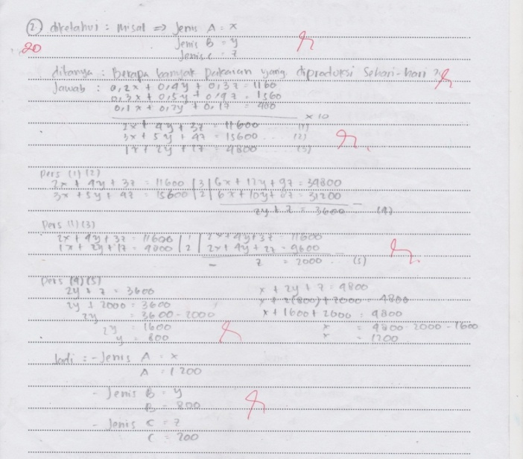
Figure 1. Completion of S1 Written story questions

The results of the S1 answers above, show that mathematical literacy is based on DAPIC problem solving at define S1 stage is able to write variable examples, write down what is asked well. Asses stage: able to write and change what is known to be a mathematical sentence. Stage plan: able to solve problems that include the ability to design mathematical models. Implement stage: able to solve mathematical story problems in detail, coherently, and correctly, Write the final results correctly. Communicate stage: able to write and draw conclusions with the right mathematical sentences. But S1 in the define stage does not write what is known from the problem. Thus, S1 achieves the specified criteria so that the final score of S1 gets a value of 7. While S2 and S3 reach the specified criteria so that the final results of scoring 6 and 7.
To delve deeper into S1 mathematical literacy in completing the given problem, there are footage of interviews with S1.
P : After you read the question number 1, what did you do?
S1 : write down the example. Type A dismissal x, type B dismissal y, and Type C in the example Z.
P : Do you have to say X, Y and Z?
S : Not. Can be for example.
P : Then, what steps do you take?
S1 : write down what was asked.
P : after you write down what was asked, what next step?
S1 : write the one in the box by marking equation (1), (2), (3) so that I can eliminate variable X.
P : after you can eliminate variable X, what next step?
S1 : get equations (4) and (5) and use substitutions to get the Y value.
P : Why did you choose the elimination and substitution method to solve equation 4 and equation 5?
S1 : because to find out y and z values is easier.
P : After the y and z values or settlement sets are found, what conclusions do you get?
S1 : Know the many clothes that must be produced every week.
P : After conclusions are obtained, does it mean that you have finished working?
S1 : Done.

S2 Mathematical Literacy Analysis for Problem no.2
Based on the problem given, the S2 is able to know well the information that is known from the problem given. Following is the resolution of the problem written by the S2.

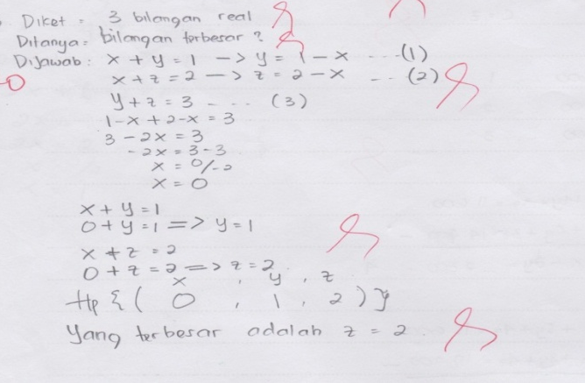
Figure 2. Completion of a written story S2

The results of the S2 answers above indicate that mathematical literacy is based on DAPIC problem solving at the define S2 stage and is able to be asked well. Asses stage: able to write and change what is known to be a mathematical sentence. Stage plan: able to solve problems that include the ability to design mathematical models. Implement stage: able to solve mathematical story problems in detail, coherently, and correctly, Write the final results correctly. Communicate stage: able to write and draw conclusions with the right mathematical sentences. But the S2 in the define stage does not write a sample variable and is unable to write what is known correctly. Thus students reach the specified criteria so that the final score of students gets a score of 6. While S1 and S3 reach the specified criteria so that the final results of scoring 6 and 7.
To delve deeper into S2 mathematical literacy in solving the given problem, snippets of interviews with S2.
P : After you read the question number 2, what did you do?
S2 : write down what is known and asked from the question
P : Then what steps do you take?
S2 : follow example x, y, z .
P : after you write the example x, y, z then what do you do?
S2 : write down the equation x+y=1, x+z=2, y+z=3
P : after you write the equation x+y=1, x+z=2, y+z=3, what is the next step ?
S2 : change x+y=1 become y=1-x and x+z=2 become z=2-x.
P : Why are you the equation?
S2 : to substitute to equation 3 to obtain the value x.
P : After the x value is found, what is the next step?
S2 : substitute the value of x to equations 1 and 2 to obtain the value y, z..
P : After getting the value of x, y z, what next step?
S2 : conclude that the largest number is 2.

S3 Mathematical Literacy Analysis for Problem no.3
Based on the problem given, S3 is able to know well the information that is known from the problem given. The following is a problem resolution written by S3.

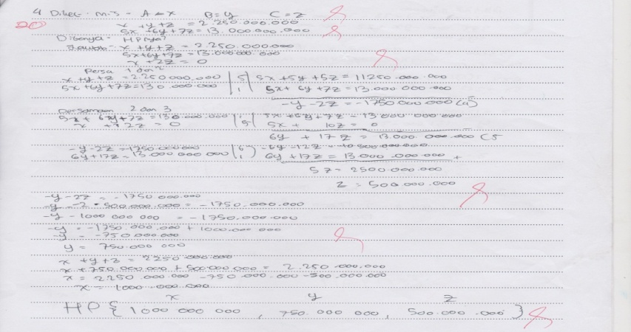
Figure 3. Completion of a story matter written by S3

The S3 answers above show that mathematical literacy based on DAPIC problem solving at define S3 stage is able to write variable examples and what is asked well. Asses stage: able to write and change what is known to be a mathematical sentence. Stage plan: able to solve problems that include the ability to design mathematical models. Implement stage: able to solve mathematical story problems in detail, coherently, and correctly, Write the final results correctly. Communicate stage: unable to write and draw conclusions with appropriate mathematical sentences. But S3 in the define stage does not write what is known. Thus students achieve the specified criteria so that the final score of students gets a score of 6. While S1 and S2 reach the specified criteria so that the final results of scoring 6 and 7.
To delve deeper into S3 mathematical literacy in solving the given problem, excerpts of interviews with S3.
P : After you read the question number 3, what did you do?
S2 : write down what is known and asked from the question.
P : Do you think the question was asked about the story?
S2 : how much is the loan for the housing company for each bank.
P : Then what steps do you take?
S2 : elimination of equations 1 with 2 and 2 with 3 .
P : why is elimination of equations 1 with 2 and 2 with 3?
S2 : to eliminate the variable x. Because in my opinion it's easiest.
P : after you eliminate the x variable, what is the next step?
S2 : obtain equations (4) and (5) so that they can be eliminated again by obtaining y and z values.
P : After obtaining the x, y z value, what is the next step ?
S2 : Already. That the company borrows Bank A is Rp. 1,000,000,000, Bank B of Rp. 750,000,000, Bank C of Rp. 500,000,000

After the data is collected, the overall data calculated to determine students' literacy skills from the stories given in the material system of three-variable linear equations (SPLTV) is as follows.

Table 4: Scores of research subjects in the X-2 IPS class at SMA Negeri 16 Surabaya as a whole
No | Subjects | Question |  |  | Total | Explanation
 |  | 1 | 2 | 3
1 | S1 | 7 | 6 | 6 | 19 | Good
2 | S2 | 6 | 6 | 7 | 19 | Good
3 | S3 | 7 | 7 | 6 | 20 | Good

DISCUSSION
Based on the results of the research that has been stated before, in this case the discussion and discussion of the results of the research concerning the research findings will be put forward.
In question number 1, from the description of the analysis carried out previously it was seen that the three subjects received a good mathematical literacy category because the three subjects wrote the answers correctly and well according to the criteria expected by the researcher. At the stage of define, asses, plan students are able to write down variable examples, write down what is asked well. Problems that include the ability to design mathematical models. Being able to solve mathematical story problems in detail, coherently, and correctly, write the final results correctly. Students are not confused to understand and define the questions in number 1 given. Students solve the problem well, because students really understand the questions given and understand the command questions. At the impement stage students write the final results and conclude the answers well. Because students are used to writing conclusions at the end of the answer. 1 criterion that has not been fulfilled from the three subjects, namely at the define stage has not written down what is well known and right.
In question number 2, from the description of the analysis carried out previously it was seen that the three subjects received a good mathematical literacy category because the three subjects wrote the answers correctly and well according to the criteria expected by the researcher. At the stage of define, asses, plan students are able to write down variable examples, write down what is asked well. problem that includes the ability to design mathematical models. Able to solve mathematical story problems in detail, coherently, and correctly, Write the final results correctly. Students are not confused to understand and define the questions in number 1 given. Students solve the problem well, because students really understand the questions given and understand the command questions. At the impement stage students write the final results and conclude the answers well for S3 while the S1, S2 do not write conclusions properly and correctly. It's just that the criteria that have not been met from the three subjects namely at the define stage have not written down what is known well and precisely.
In question number 3, from the description of the analysis carried out previously it was seen that the three subjects received a good mathematical literacy category because the three subjects wrote the answers correctly and well according to the criteria expected by the researcher. At the stage of define, asses, plan students are able to write down variable examples, write down what is asked well. problem that includes the ability to design mathematical models. Able to solve mathematical story problems in detail, coherently, and correctly, Write the final results correctly. Students are not confused to understand and define the questions in number 1 given. Students solve the problem well, because students really understand the questions given and understand the command questions. At the impement stage students write the final results and conclude the answers well for S1, S2 while S3 does not write conclusions properly and correctly. Because S3 thinks that writing a set of solutions is a conclusion that is asked for a question. The same criteria that have not been met from the three subjects namely at the define stage have not written down what is well known and right.
Based on the results of the analysis, the researcher draws the conclusions that students do not write what is known well and precisely because the three subjects assume writing by example and the mathematical sentence is a known stage of the problem. do not write conclusions properly and correctly. The work results of the three overall subjects in solving the story problems in the material system of linear equations three variables with questions as many as 3 items in class X-2 IPS SMA Negeri 16 Surabaya, S1 obtained a score of 19, S2 obtained a score of 19, and S3 received a score of 20. With thus, the mathematical mathematical literacy skills of Social Sciences X-2 students at SMA Negeri 16 Surabaya in solving mathematical problems in the form of story questions based on DAPIC (Define, Asses, Plan, Implement, Communicate) problem solving are in the good category.

- CONCLUSION
Based on the results of the study showed that the three subjects, at the define stage students did not write down what was known well and precisely because the three subjects thought that writing with an example and a mathematical sentence is a known stage of the problem. In the communication stage students do not write conclusions properly and correctly. It can be concluded that the three subjects obtained an overall score in solving the story questions in the material system of linear equations three variables with questions as many as 3 items in the X-2 IPS class of SMA 16 Surabaya, the researcher got a score category of achievement of students' overall mathematical literacy, namely categories So .. Thus, the mathematical mathematics lieration ability of Social Sciences X-2 students at SMA Negeri 16 Surabaya in solving mathematical problems in the form of story problems based on DAPIC (Define, Asses, Plan, Implement, Communicate) problem solving is in the good category.

ACKNOWLEDGMENTS
We would like to thank the rector of Universitas Negeri Surabaya, the postgraduated director of Universitas Negeri Surabaya, and all teachers as the partipants involved in this programme.

REFERENCES

Abdurrahman, Mulyono. 2012. Anak Berkesulitan Belajar: Teori, Diagnosis, dan Remediasinya. Jakarta: PT. Rineka Cipta.
Arifin, Zainal. 2012. Penelitian Pendidikan Metode dan Paradigma Baru. Bandung: PT. Remaja Rosdakarya.
Komara, Endang. 2014. Belajar dan Pembelajaran Interaktif. Bandung: Refika aditama
Nevi Trianawaty, St. Budi Waluya, Supriyadi. (2018). Abilities of Mathematical Literacy Based on Self-Confidence in Problem Based Learning with DAPIC Problem-Solving Process. UJMER 7 (Unnes Journal Of Mathematics Education Research). 152-160
OECD. (2007). PISA 2006: Science competencies for tomorrow’s world. https://222.oecd.org/dataoecd/15/13/39725224.pdf Diakses pada tanggal 13 April 2019
OECD. (2016). PISA Result in Focus 2015. https://www.oecd.org/pisa/pisa-2015-results-in-focus.pdf. Diakses pada 13 April 2019.
Polya G. (1973). How to Solve: A New Aspect of Mathematical Method. Princetion: PPrincenton Universitu Pres.
Suherman, E. (1993). Evaluasi Proses dan Hasil Belajar Matematika. Jakarta: Dirjen Dikdasmen Depdikbud
Sunisa Sumirattana, Aumporn Makanong & Siriporn Thipkong. (2017). Using Realistic Mathematics Education and The DAPIC problem-solving process to enhance secondary school students mathematical literacy. Kasetsart Journal of Social Sciences. 307-315
Wicaksana Y, Wardono & Ridlo. (2018). Analisi Kemampuan Literasi Matematika dan Karakter Rasa Inging Tahu Siswa pada Pembelajaran Berbasis Proyek Berbantuan Schoology. Prisma 1 (Unnes Journal Of Mathematics Education Research). 418-425

