Validating Technology Attitude Scale for Pre-Service Mathematics Teachers: Rasch Person-Item Fit Analysis
Abstract. The purpose of the study was to evaluate the person and item fit of technology attitude scale for pre-service mathematics teachers (n = 106) using Rasch measurement. This study was conducted using Winsteps, and the fit analysis was employed several times. First, the items and persons fit were examined to check the existence of extreme responses. Second, the extreme responses were eliminated based on the item and person. Third, the underfit persons were deleted. Lastly, the misfitting items were eliminated. The person and item fit evaluation were based on three criteria; (1) Outfit mean square (MNSQ) value, (2) Outfit Z-standard (ZSTD) value, and (3) Point Measure Correlation value. The result reveals that there are five outliers in term of person. Consequently, they should be eliminated. Then item fit test was conducted, and it shows that two items (item19 & item20) have the extreme value of outfit indices, then it could not be retained. The further analysis continues with 101 persons and 18 items that are good and indicate the sufficient fit to Rasch model for practical measurement purposes.
Keywords: item fit, person fit, pre-service mathematics teachers, Rasch model, technology attitude scale.
Introduction
Teachers nowadays should be adaptive to technology development, which can help them to facilitate students’ learning in every subject, especially the core one, mathematics. The consideration of technology as an essential component of teacher knowledge meets the need that Indonesia has changed the school curriculum recently, with limited face to face time for mathematics subject. The use of technology will help the teacher to do the flipped classroom as the new approach because it can change the management of time and activities either in class or out-of-class, pre or post-meeting session, traditional or modern approach, and individual or social (1).
Learning and teaching mathematics with technology is a complicated process requiring a teacher to expert several core competencies (2). Teachers need to deal with the fact of how the new device, the new representation, and alternative learning strategies made available by technology depend on the diverse factors of a teaching situation: content to be taught, curriculum, specificities of students and more generally of the learning context (3).
One of the factors which can encourage teachers to use technology in their teaching is the attitude. The attitude of a person is described as a predisposition to approach or avoid an idea, event, and person or object (4). In other words, it is a tendency to act in one way or another toward an attitude object. In the term of teacher education, (5) stated that teachers’ attitude is an important consideration to understand classroom practices and conduct teacher education because it strongly affects what and how the in-service and pre-service teachers learn and develop their thinking and practices. Teacher education and teachers’ professional development had the intention to increase teachers’ skill and build teachers’ confidence in using technology. The causation refers to be that if the teacher had adequate access to technology, they would integrate technology into their teaching.
To make sure that future teachers will integrate technology into their class instruction, they must have the right attitude towards technology. Researchers have been concerned with this issue showed by some studies regarding attitude towards technology. Moreover, several of them have established necessary instruments measuring teachers’ attitude towards technology. Loyd & Loyd (6) developed the Computer Attitude Scale (CAS) to evaluate teachers’ attitude towards the computer. A survey was also designed to assess teachers’ perception of educational technology on computers and media such as film and video (7). Davis (8) formed an instrument named Technology Acceptance Model (TAM), which included usefulness and ease of utilisation. This study used Technology Attitude Scale that was constructed by McFarlane, Hoffman, & Green (9). The Technology Attitude Scale was created differently from the prior instruments since it assessed teachers’ attitude towards various technology generally instead of only computers, film, and video. Besides, it included educational utility items which were essential to teachers’ attitude. The Technology Attitude Scale (TAS) was validated by employing principal component analysis that considered dimensionality, factor loading, variance, and reliability (9). The study found out that the 20-items of TAS were valid and reliable.
Validation using principal component analysis or factor analysis is generally known. However, there is another type of validation for an instrument named Rasch Model. Rasch model is one-parameter Item Response Theory (IRT) model, which can overcome classical test theory (CTT) problem by producing items and person statistics independent (10). The analysis of Rasch is a psychometric technique that was established to improve the accuracy with which researchers create instruments, monitor instrument quality, and compute respondents’ performances (11). Rasch analysis enables researchers to construct alternative forms of measurement instruments. Rasch analysis also helps researchers think in more complex ways concerning the constructs (variables) they wish to measure. Bond & Fox (12) stated that the Rasch model focuses on a person who has ability to encountering an item which has the level of difficulty and the likelihood of the person gets the items correct. Probability of success depends on the difference between the ability of the person and the difficulty of the item. The advantages of using Rasch model for validation are (a) generating linear measure, (b) accommodating missing data, (c) providing validity and reliability, (d) presenting independent and accurate estimation, and (e) focusing on the individual person and item performance instead of a group (13,14). Using Rasch model, several properties represent validity analysis. However, this study only aimed attention at variable (Wright) maps and fit statistics. Wright Maps is a graph representing the relationship between the measures of persons and items (15). The fit defines how appropriate data correspond to Rasch model (15), and it can be obtained by comparing the expected and observed responses (13). Item fit is used to examine items’ contribution to unidimensional construct. The model expects that an item has a bigger chance of obtaining a higher rating for a person with higher ability. Person fit refers to a person’s responses pattern to the items concerning the model. The expectation is that a person having higher ability tends to have a higher rating. The items and persons categorised as misfitting should be considered to revise or eliminate (13). Using a procedure developed by Wright, the person and item fit evaluation were based on three criteria; (1) Outfit mean square (MNSQ) value, (2) Outfit Z-standard (ZSTD) value, and (3) Point Measure Correlation value (15).
Based on the review above, it can be derived that validating Technology Attitude Scale for pre-service teachers is reasonably promising, particularly in the Indonesian context with no prior research regarding it. Therefore, this study aimed to evaluate the person and item fit of technology attitude scale for pre-service mathematics teachers using Rasch measurement. The results of the study could be the considerations for the researcher to create a new instrument or revise the existed instrument regarding the technological attitude of pre-service mathematics teachers. The study would also give empirical evidence to support the theoretical framework, which has been established in the previous study.
Methodology
This study was a quantitative survey design with the type of cross-sectional study. It investigated medium-scale participants, and the data were collected from questionnaires. The participants in this study were pre-service teachers who will be Mathematics school teachers at two teachers’ education institutions (universities) in Indonesia. When they were invited to participate in this research, they had to have completed at least one of the Information and Communication Technology-related course. The number of total participants in this study was 106 (n = 106) who came from two teachers’ universities and who were drawn from the 2013 – 2016 yearly intakes.
This study adapted an instrument developed by McFarlane (9), the “Technology Attitude Survey” with 20 items to assess teachers’ attitudes towards the general use of technology as an educational tool in the classroom. There were several modifications to the items based on the appropriateness for pre-service Mathematics teachers, such as changing the terms from “technology” into “ICT” and from TTFLT (Language Teachers) into the general. This study also removed item number 6 due to the biased statement and expanded item number 19 into two new ones since it represented two conditions. Hence, the research instrument was a questionnaire which consisted of 20 items for measuring attitudes towards ICT. Each of the items has four levels of the agreement which are represented by a four-point Likert scale: strongly disagree (1), disagree (2), agree (3), and strongly agree (4). Before running the data analysis, nine-item responses in the questionnaire which measured attitudes towards ICT were recoded due to the original coding and the direction of tendency, as shown in table 1.
Table 1. Recoded items of the research questionnaire
Latent Variable | Observed Variable | Item | Initial Coding | Final Coding
Technology Attitude Scale | item4  item7  item9  item10  item11  item12  item17  item18  item19 | Working with ICT makes me nervous  ICT makes me feel stupid  I don’t expect to use ICT much at work  I am not the type to do well with ICT  I feel uncomfortable using most ICT tools  Working with ICT is boring  I think using ICT will be difficult for me  ICT makes me feel uneasy  I get confused when using ICT | 1 = Disagree a lot  2 = Disagree a little  3 = Agree a little  4 = Agree a lot | 1 = Agree a lot  2 = Agree a little  3 = Disagree a little  4 = Disagree a lot

This study was conducted using Winsteps, and the fit analysis was employed several times. First, the items and persons fit were examined to check the existence of extreme responses. Second, the extreme responses were eliminated based on the item and person. Third, the underfit persons were deleted. Lastly, the misfitting items were eliminated. The person and item fit evaluation were based on three criteria; (1) Outfit mean square (MNSQ) value, (2) Outfit Z-standard (ZSTD) value, and (3) Point Measure Correlation value. The acceptable range of outfit MNSQ is 0.5 < MNSQ < 1.5, that of outfit ZSTD is $-$2.0 < ZSTD < +2.0, and that of point measure correlation is 0.4 < Pt. Measure Correlation < 0.85 (15,16).

Result and Discussion
The analysis was begun by examining the item fit. Table 2 shows the misfit order of the item. The mean of infit MNSQ is 1.01, with a standard deviation of 0.25. It means that infit MNSQs of several items do not fall within the acceptable range. Based on the outfit MNSQ criterion, item20 is categorised as underfitting. The analysis of outfit ZSTD also identifies several misfitting items. The initial assumption of these misfits is the existence of unexpected responses given by the participants. Therefore, the next steps are conducted to eliminate those responses based on items and persons.
Table 2. Initial Analysis of Item Fit
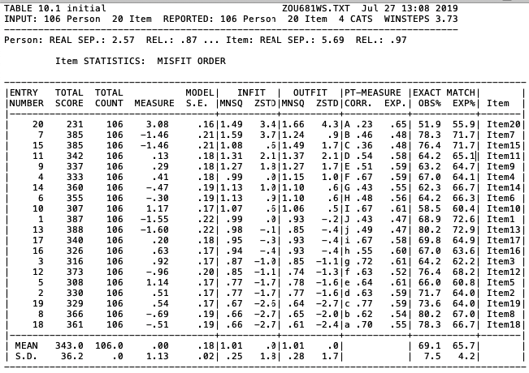
Examining unpredictable answers is administered by identifying response which has z-residual of 2 or higher, or has more negative than $-$2. The next step is removing those unexpected responses and investigate the impact on the item fit. Table 3 presents the unpredicted answers based on misfitting items, and table 4 shows those responses according to misfitting persons.
Unexpected response removal based on misfitting items has been done, and fit-indices in table 5 stage 2 explain that there is no significant change, which means it needs to remove some outliers based on the misfitting person. Initial person-fit analysis (table 6, stage 1) identifies many persons misfitting, but it does not need to get rid of them straight away. We encounter losing many data if we remove them all. We have to investigate which responses caused unexpected answer (Table 4). Therefore, we need to remove the unexpected response from poorly fitting person to get more appropriate data set. Table 5 shows there is no difference in stage 3 column, which demonstrates that removing responses based on the item and person misfit is not sufficient. The person removal is still needed to clean the data from person outlier.

Table 3. Unexpected responses based on misfitting item
Item number | Person number
 | z-residual of 2 or higher | more negative than $-$2
Item20 | 31,39,48,61,94,104 | 62
Item7 | - | 47,98
Item15 | 94 | 82
Item11 | 52 | 59,73
Item9 | 21 | 103
Table 4. Unexpected responses based on misfitting person
Person number | Item number
 | z-residual of 2 or higher | more negative than $-$2
10 | 9,16 | 4,17,19
55 | 16 | 7,10
94 | 1,13,14 | -
45 | 10 | 13
95 | - | 15
96 | - | 6
52 | 2 | -
78 | - | 1,15
62 | - | 10
71 | - | 4
31 | 6 | 17
Table 5. Misfitting items in initial and final analysis
Item fit criteria | Misfitting item number
 | Stage 1 | Stage 2 | Stage 3 | Stage 4
0.5 < outfit MNSQ < 1.5  Underfit  Overfit | 20,15 | - | 20 | 20
$-$2.0 < outfit ZSTD < +2.0  Underfit  Overfit | 20,11  19,8,18 | 20  19,18 | 20  18,19 | 20  19
0.4 < Pt. Measure Correlation < 0.85 | 20,15 | 20 | 20 | 20
Deleted |  |  |  | 20,19
Person fit analysis was employed again, and the result is presented in Table 6 stage 2. The finding identifies five persons who do not meet the criteria and categorised as underfitting, then they should be eliminated from the data. Underfit persons tend to mislead the measurement (15), therefore, in order to obtain suitable data to the Rasch model, those should be removed. Although overfit persons could cause redundancy, they could be retained because the more strict rule should only be applied to the item (15).

Table 6. Misfitting persons in initial and final analysis
Person fit criteria | Misfitting person number
 | Stage 1 | Stage 2
0.5 < outfit MNSQ < 1.5  Underfit  Overfit | 10,55,94,45,49,95,96,74,52,  54,80,101,13  48,100,1,63,30,43,20,39,53,  22,24,93,87,41 | 10,54,49,74,80,95,101,52,47,  5,88,36,94,55,76  1,100,63,39,20,30,43,22,24,  53,93,87,41
$-$2.0 < outfit ZSTD < +2.0  Underfit  Overfit | 10,55,94,45,49,95,96,74,52,  54  100,1,63,30,43,20,39,22,24,  93,87,41 | 10,54,49,74,80  1,100,63,39,20,30,43,22,24,  53,93,87,41
0.4 < Pt. Measure Correlation < 0.85 | 55,49,78,62,13,75,71,29 | 49,75,94,55,77,92
Deleted |  |  | 10,54,49,74,80

Table 7. Final Analysis of Item Fit
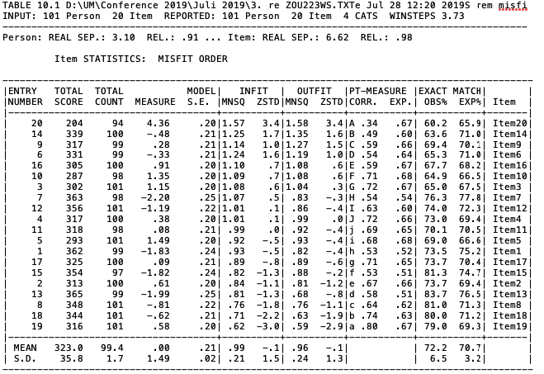
The data has been clear from unexpected responses and poorly fit persons. Therefore, the final analysis focuses on how well the items work. The final analysis has infit MNSQ mean of 0.99 and a standard deviation of 0.21. The finding is shown in Table 5 stage 4 and table 7, which indicates that item 20 and item 19 do not fall within the acceptable range. The outfit MNSQ and ZSTD of item20 is categorised as underfitting that means it does not appropriately reflect the construct. Item 19 has a deficient level of outfit MNSQ and ZSTD, and it could not satisfy the requirement of objective measurement. Therefore, item 19 is identified as a redundant item. Linacre and Boone (15,17) stated that items should be behaving better than the person. In accordance with that, both the underfit and overfit item should be eliminated.

Table 8. Items deleted
Item number | Item (English) | Item (Bahasa)
19 | I get confused when using ICT | Saya bingung saat menggunakan TIK.
20 | Once I start using ICT, I will find it hard to stop | Begitu saya mulai menggunakan TIK, saya akan kesulitan untuk berhenti.

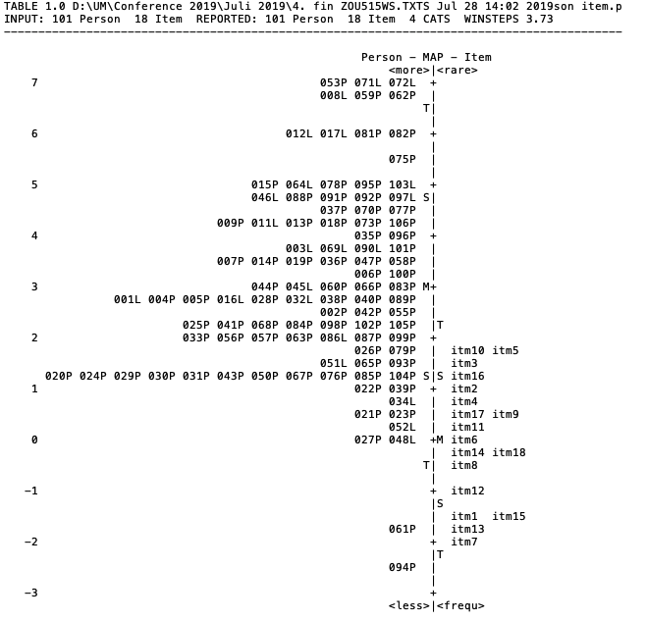
Figure 1. Wright maps in Final Analysis
Table 9. Items measure similar portions
 | Item
1 | Item10 | I am not the type to do well with ICT
 | Item5 | I now use my knowledge of ICT in many ways as a teacher
2 | Item17 | I think using ICT will be difficult for me
 | Item9 | I don’t expect to use ICT much at work
3 | Item14 | It is important to know how to use ICT in order to get a teaching position
 | Item18 | ICT makes me feel uneasy
4 | Item1 | Knowing how to use various ICT tools is a necessary skill for me
 | Item15 | I know that if I work hard to learn about ICT, I will do well
The further analysis continues with 101 persons and 18 items that are good and indicate the sufficient fit to Rasch model for practical measurement purposes. Besides, some other properties of the Rasch model should be used as consideration in developing the instruments. Wright Maps is a graph representing the relationship between the measures of persons and items (15). The Wright maps of this study is presented in figure 1. Many participants readily agree almost all of the items indicated by the higher level of mean than the items. There is also a little gap between item8 and item 12 and between item 12 and item 1. The analysis also suggests some changes in the consecutive form of instruments. Item 10 and item 5 appear to measure identical part of the attribute, and therefore, from measurement view, are redundant. This appears to also to be the case for items 17 and 9, items 14 and 18, and items 1 and 15. There will be only little measurement loss when those individual items are deleted.
Conclusion
The result reveals that there are five outliers in term of person. Consequently, they should be eliminated. Then item fit test is conducted, and it shows that two items (item19 & item20) have the extreme value of outfit indices, and it could not be retained. The further analysis continues with 101 persons and 18 items that are good and indicate the sufficient fit to Rasch model for practical measurement purposes.
Reference

1. Abeysekera L, Dawson P. Motivation and cognitive load in the flipped classroom: definition, rationale and a call for research - Higher Education Research & Development - Volume 34, Issue 1. Routledge Taylor & Francis Group. 2015;34(1):1 – 14.
2. Thomas MOJ, Hong YY. Teacher Integration of Technology into Mathematics Learning. International Journal for Technology in Mathematics Education. 2013 Apr;20(2):69–84.
3. Grugeon B, Lagrange J-B, Jarvis D, Alagic M, Das M, Hunscheidt D. Teacher Education Courses in Mathematics and Technology: Analyzing Views and Options. In: Hoyles C, Lagrange J-B, editors. Mathematics Education and Technology-Rethinking the Terrain [Internet]. Springer US; 2009 [cited 2016 Jun 8]. p. 329–45. (New ICMI Study Series). Available from: http://link.springer.com.proxy.library.adelaide.edu.au/chapter/10.1007/978-1-4419-0146-0_15
4. Johnston H. Shaping beliefs and attitudes: A handbook of attitude change strategies. University of Florida, Florida; 2001.
5. Richardson V. The role of attitudes and beliefs in learning to teach. Handbook of research on teacher education. 1996;2:102–119.
6. Loyd BH, Loyd DE. The Reliability and Validity of an Instrument for the Assessment of Computer Attitudes. Educational and Psychological Measurement. 1985;45(4):903–908.
7. Lowther DL, Sullivan HJ. Teacher and technologist beliefs about educational technology. Educational Technology Research and Development. 1994;42(4):73–87.
8. Davis FD. User acceptance of information technology: system characteristics, user perceptions and behavioral impacts. International Journal of Man-Machine Studies. 1993;38(3):475–87.
9. McFarlane TA, Hoffman ER, Green KE. Teachers’ Attitudes toward Technology: Psychometric Evaluation of the Technology Attitude Survey. 1997 Mar [cited 2017 Sep 6]; Available from: https://eric.ed.gov/?id=ED411279
10. Fan X. Item Response Theory and Classical Test Theory: An Empirical Comparison of their Item/Person Statistics. Educational and Psychological Measurement. 1998 Jun 1;58(3):357–81.
11. Boone WJ. Rasch Analysis for Instrument Development: Why, When, and How? CBE Life Sci Educ [Internet]. 2016 [cited 2017 Aug 21];15(4). Available from: http://www.ncbi.nlm.nih.gov/pmc/articles/PMC5132390/
12. Bond T, Fox CM. Applying the Rasch Model: Fundamental Measurement in the Human Sciences, Third Edition. Routledge; 2015. 406 p.
13. Smith EV, Conrad KM, Chang K, Piazza J. An Introduction to Rasch Measurement for Scale Development and Person Assessment. Journal of Nursing Measurement. 2002 Dec 1;10(3):189–206.
14. Wright BD, Mok MMC. An overview of the family of rasch measurement models. Introduction to rasch measurement: Theory, models and applications. 2004;1–24.
15. Boone WJ, Staver JR, Yale MS. Rasch Analysis in the Human Sciences [Internet]. Springer, Dordrecht; 2013 [cited 2019 Jul 17]. Available from: https://link.springer.com/book/10.1007%2F978-94-007-6857-4
16. Sumintono B, Widhiarso W. Aplikasi model Rasch untuk penelitian ilmu-ilmu sosial (edisi revisi). Cimahi, Indonesia: Trim Komunikata Publishing House; 2014. 162 p.
17. Linacre JM. Sample size and item calibration stability. Rasch measurement transactions. 1994;7(4):328.

Acknowledgments

Author would like to thank to Indonesian Endowment Fund for Education for the financial support during the completion of the study and research.

